JAMES COOK UNIVERSITY

SCHOOL OF ENGINEERING

EG4011

Three Dimensional Consolidation

Samantha Thomas

Bachelor of Engineering

(Civil)

May 10th, 2013

Contents

Chapter 1: Introduction 1

1.1 Project Objectives 2

Chapter 2: Literature Review 4

2.1 Soil Property Overview 4

2.2 Consolidation Theory 5

2.3 One-Dimensional Consolidation 7

2.3.1. Total Consolidation Settlement (sc) 7

2.3.2. Consolidation Testing 9

2.3.3. Void-Log $σv'$ Plot 10

2.3.4. Terzaghi’s One Dimensional Consolidation Theory 12

2.3.5. Calculating Coefficient of Consolidation (cv) 18

2.4 Two and Three Dimensional Consolidation 22

2.4.1. Two and Three Dimensional Consolidation Theories 22

2.5 Application – Land Reclamation 24

2.5.1. Port of Brisbane, Queensland, Australia 25

Chapter 3: Research and Methodology 27

3.1 Objectives 27

3.2 Methodology 27

3.2.1. Experimental Analysis 27

3.2.2. Analytical Analysis 31

3.2.3. Numerical Analysis 31

Chapter 4: Project Management Plan 32

4.1 Timeline 32

4.2 Resource Planning 33

4.3 Risk Analysis 33

4.4 Cost Analysis 34

APPENDIX A-RAW DATA 36

A-1 Matlab Code for Average Degree of Consolidation-Time Factor Graph 36

A-2 Tall Oedometer Procedure for Preparation of Slurry Sample 37

A-3 Detailed Experimental Timeline 39

A-4 Risk Analysis 41

1. **Introduction**

Consolidation is the compression of a soil stratum that occurs due to the application of stress, and as a result of the dissipation of water from voids in a saturated soil. Consolidation settlement can result in many problems for structures built upon a consolidating layer, and therefore correct estimation of the magnitude and rate of the settlement is required.

One dimensional consolidation is generally used to quantify the magnitude and rate of consolidation. Terzaghi’s (1925) theory quantifies the time rate of consolidation in one dimension by assuming strains and drainage occurs in the vertical plane only. Terzaghi’s theory is often used to calculate consolidation settlement. Due to two and three dimensional consolidation conditions in field situations, it is evident that the rate of consolidation settlement that is actually experienced is greater than that obtained using one dimensional consolidation theory (Davis and Poulos 1972). Davis and Poulos (1972) attributed this to the horizontal dissipation of pore pressure that occurs in two and three dimensions, resulting in the consolidation of a clay layer occurring more rapidly than predicted by the one-dimensional consolidation theory.

Two and three dimensional consolidation theories have been developed by Terzaghi (1925) and Rendulic (1937) based on the diffusion theory, and by Biot (1941) in his elastic theory (Razouki and Al-Zayadi (2003); Poulos and Davis (1968)), however due to the difficulty of these theories and minimal theoretical practical solutions having been obtained, one dimensional consolidation theory is generally used (Davis and Poulos 1972).

The determination of two and three dimensional consolidation has many field applications. This includes land reclamation, with such examples including the Port of Brisbane, Queensland where land reclamation is currently being undertaken. The Port of Brisbane utilises dredged materials as fill, providing both economic and environmental benefit.

Unfortunately, the dredged material is comprised of silts and clays in a slurry form with extremely high water content, resulting in poor drainage properties. The containment bunds are underlain by a Holocene clay layer of up to 30 m in depth, further underlain by an extremely stiff Pleistocene. This results in both the dredged material and in situ material having poor drainage and high compressibility (Ganesalingam et al. 2012a)

The estimation of the rate of settlement is difficult due to limitations in consolidation theory, with one dimensional consolidation theory overestimating the time taken for consolidation to be achieved and therefore increasing the time and cost involved. This highlights the importance and necessity of the time rate of two and three dimensional consolidation to be quantified.

## Project Objectives

In this study, analytical, experimental and numerical solutions will be obtained to quantify the rate of two and three dimensional consolidation.

Experimental solutions will be attained for two and three dimensional laboratory consolidation tests through the use of a new apparatus allowing the appropriate drainage conditions.

An analytical solution will be derived that allows the user to vary the consolidation parameter inputs and determine the rate of consolidation based upon these. Through the use of MATLAB, a generalised theory will be implemented and the user will be able to input the property of the coefficient of consolidation and variables such as initial excess pore water distribution and time dependent loading.

A numerical solution will be derived using the finite element analysis software FLAC, where validation will be achieved through comparison with experimental solutions. This will allow the model to be further extended to scenarios not modelled in the laboratory.

The intended objectives are therefore to:

* Develop a functional two dimensional and three dimensional consolidation apparatus;
* Quantify anisotropy in the coefficient of consolidation of a soil through standard one dimensional consolidation tests of both horizontally and vertically cut samples, and validate by obtaining both vertical and horizontal permeability values in a consolidation cell equipped with permeability capabilities;
* Develop design charts of average consolidation curves (*U-T* curves) for:
  + a range of ratios of the coefficient of vertical consolidation (*cv*) to the coefficient of horizontal coefficient (*ch*) ( ratios) obtained numerically, and analyse the relationship of this curve with respect to the one dimensional *U-T* curve.
  + two dimensional consolidation by varying the height to diameter (*H/d*) ratio numerically and analysing with respect to the one dimensional *U-T* curve.
  + three dimensional consolidation by varying the height to length ratio numerically and analysing with respect to the one dimensional *U-T* curve.
* Develop a relationship between the overconsolidated and normally consolidated coefficient of vertical consolidation obtained during one dimensional consolidation testing;
* Develop a numerical model in FLAC to determine the rate of consolidation in real applications including the Port of Brisbane where a two layered, non-homogeneous consolidating layer with partial drainage boundaries with a non-uniform distribution of excess pore water pressure and time-dependent surcharge loading is evident.

# Literature Review

## Soil Property Overview

A soil is a particulate media consisting of three phases; gas, liquid (commonly air and water respectively) and soil grains. The total normal stress present on a soil stratum can be determined by summating the stress of the soil grains (inter-granular/effective stress) and stress present on the voids within a saturated soil (pore pressure/neutral stress), as evident in Equation 2.1 (Sivakugan and Das 2009).

|  |  |  |
| --- | --- | --- |
|  | $$σ= σ^{'} + u$$ | (2.1) |

A soil can be classified as either coarse or fine-grained. Fine grained soils are further classified into clays or silts, with a grain size less than 0.075 mm as outlined in AS1726-1993. This thesis will focus on cohesive soils, fine- grained soil that gains shear strength through the bonding of soil particles. A cohesive soil is plastic in nature and can be moulded when wet. Silts have little to no plasticity, and hence clays will be the focus.

#### Permeability of a Soil

Permeability of a soil results from the presence of interconnected voids, as water flows from points of high energy to points of low energy (Das 1984). The rate of flow is dictated by Darcy’s law (1856) where the flow is directly proportional to the coefficient of permeability (hydraulic conductivity) of the soil. The coefficient of permeability (*k*) varies with soil type and is dependent on factors including pore size distribution, void ratio, saturation and structure. Due to the smaller particle size, and therefore the presence of a smaller void ratio in clays, a permeability that is one million times smaller is often evident in clays when compared to sands (Coduto 1998). This emphasises the poor drainage properties of the dredged materials at the Port of Brisbane as they are comprised of silts and clays, and highlights the benefit of using sands and gravels for land reclamation.

#### Anisotropy of a Soil

An anisotropic material is one in which the elastic properties depend on the orientation of the sample and often refers to soil structure, soil strength and soil permeability in different directions (Peng 2011). This differs to an isotropic material where the sample will exhibit the same elastic properties in all orientations. Both horizontal permeability (*kh*) and vertical permeability (*kv*) are observed in an anisotropic material, however isotropic materials only consider vertical permeability to be a factor (Graham and Houlsby 1983).

Anisotropy of clay arises due to two components; inherent anisotropy and stress-induced anisotropy as outlined by Sivakugan et al. (1993) in describing the undrained strength anisotropy of a clay. Inherent anisotropy refers to the way in which the soil was deposited where a preferred particle orientation occurs. As stated by Graham and Houlsby (1983) the periodic deposition of finer and coarser particle sizes within a natural clay will result in a permeability that is anisotropic. Ti et al. (2009) noted that a soil often shows anisotropic behaviour when subjected to stresses. Stress-induced anisotropy refers to the stress at the end of consolidation where anisotropy results from the direction of loading dependent upon the initial anisotropic stress state (Sivakugan et al. 1993).

## Consolidation Theory

Consolidation is defined as the compression of a soil stratum that occurs due to the application of stress. Within a saturated soil, volume decrease (compression) of the soil takes place as a result of the reduction of the volume of voids through expulsion of water. As the solid matter and pore water are assumed to be incompressible, the resulting settlement can be attributed solely to this reduction in void volume

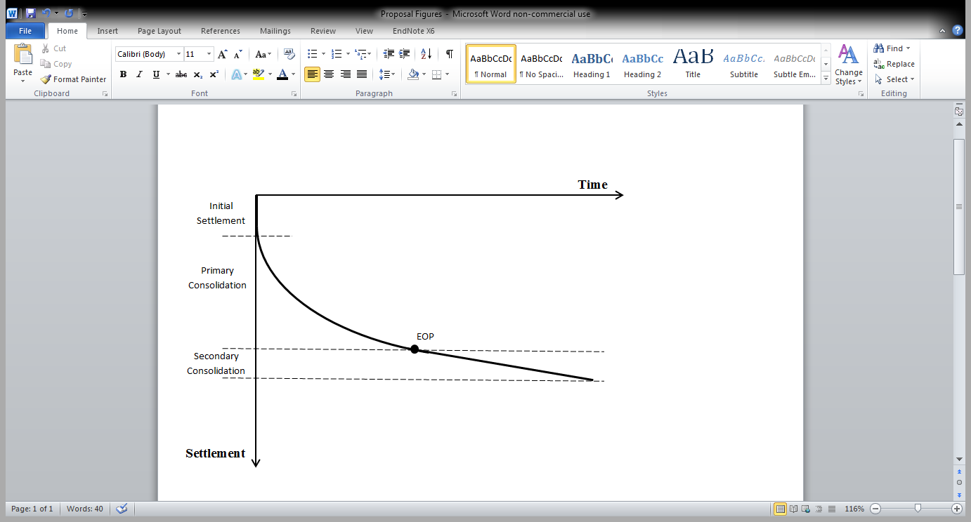Total settlement of a soil stratum is the contribution of consolidation settlement, in addition to an initial elastic settlement that occurs immediately after, and due to the application of load (Figure 2.1), and does not cause a change in moisture content of the soil. Consolidation settlement comprises two components; primary consolidation settlement, and secondary consolidation settlement, also referred to as creep.

**Figure 2.1: Settlement – Time Relationship**

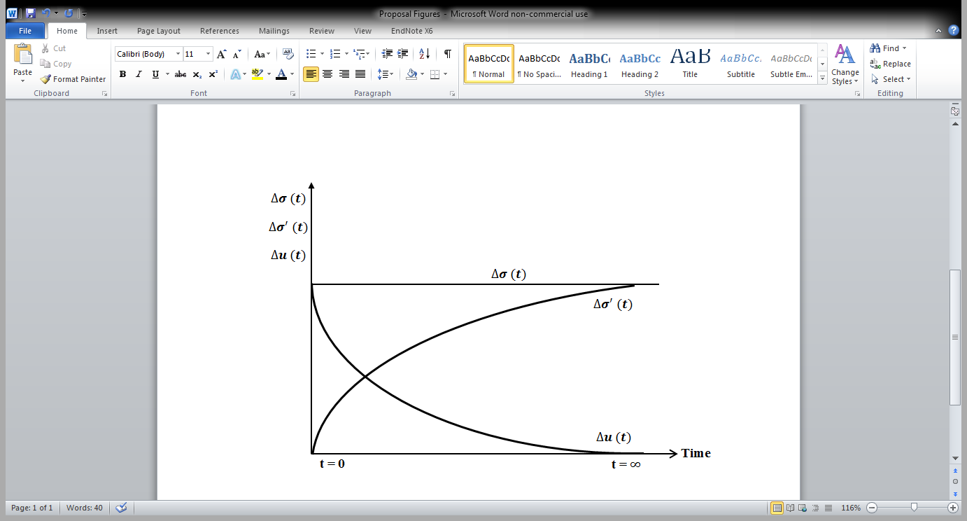Primary consolidation settlement is the process of volume reduction that occurs within a soil mass as a stress is applied. Initially when a stress is applied, pore water carries the entire deviatory load *($∆σ= ∆u$*), producing an excess pore water pressure. The excess pore water pressure gives rise to a hydraulic gradient that results in the dissipation of water from voids (Coduto 1998). The deviatory load is transferred to the soil skeleton with the dissipation of pore water, and with time, the soil skeleton will carry the entire deviatory load ($∆σ= ∆σ^{'})$. This process is evident in Figure 2.2.

**Figure 2.2: Change in components of total stress with time**

Secondary consolidation settlement occurs at a constant effective stress and results in additional compression of the soil. It occurs at the end of primary consolidation, and as a result of the rearrangement of the soil fabric of the clay layer (Das 1984).

The time period of consolidation is dependent on many factors, including the permeability of the soil, the length of the drainage path and the magnitude of the applied stress (Barnes 1995). Due to the high permeability of a cohesionless soil, total settlement occurs almost immediately. As cohesive soils are less permeable, consolidation is time-dependent and total settlement occurs over a prolonged period of time. The time rate of one-dimensional consolidation is quantified using Terzaghi’s (1925) theory, as evident in Section 2.3.4.

Consolidation in the field can occur in one, two or three dimensions, however calculation of consolidation settlement and time taken for consolidation to occur are often calculated in one dimension. This is due to the availability and simplicity of analytical equations and experimental apparatus in one dimension. Two and three dimensional consolidation considers horizontal dissipation of pore pressure, resulting in the consolidation of a clay layer occurring more rapidly than predicted by the one-dimensional consolidation theory (Davis and Poulos 1972).

## One-Dimensional Consolidation

Consolidation can be considered to be one dimensional when the applied stress on the soil stratum extends a large width compared to the depth of the soil. This loading situation results in strains and drainage in the vertical plane only.

### Total Consolidation Settlement (sc)

Total consolidation settlement in one dimension is directly related to the change in height – change in void relationship developed by equivalence of average vertical strain, as evident in Equation 2.2.

|  |  |  |
| --- | --- | --- |
|  | $$\frac{∆H}{H_{0}}= \frac{∆e}{1+e_{0}}$$ | (2.2) |

where:

$∆H$ = the decrease in thickness of the consolidated clay later

*H0*= the initial height of the clay layer

$∆e$ = the change in void ratio

*e0* = the initial void ratio.

Total consolidation settlement (*sc*) can be determined through the relationship of the change in volume of the soil stratum to the coefficient of volume compressibility (*mv*) in one dimension by Equation 2.3.

|  |  |  |
| --- | --- | --- |
|  | $$s_{c}=m_{v}{∆σ}^{'}H_{0}$$ | (2.3) |

where:

${∆σ}^{'}$ = change in effective stress

*mv* = coefficient of volume compressibility

The coefficient of volume compressibility is dependent upon the applied load, and therefore varies within the consolidating layer (Aysen 2002). This method relies on the availability of *mv* and requires the stress level expected to be known to calculate total consolidation settlement (Sivakugan and Das 2009).

The coefficient of volume compressibility can be related to the compression index (*Cc*) (see Section 2.3.3) in a normally consolidated clay as evident in Equation 2.4. It can also be related to the drained Young’s modulus (*E*), constrained modulus (*D*) and Poisson’s ratio ($ν$) through Equation 2.5.

|  |  |  |
| --- | --- | --- |
|  | $$m_{v}= \frac{0.434 C_{c}}{\left(1 + e_{0}\right){σ^{'}}_{average}}$$ | (2.4) |

where:

${σ^{'}}_{average}$ = the average effective stress throughout consolidation

|  |  |  |
| --- | --- | --- |
|  | $$D= \frac{1}{m_{v}}= \frac{(1- ν)}{\left(1+ ν\right) (1-2ν)} E$$ | (2.5) |

where:

|  |  |  |
| --- | --- | --- |
|  | $$D= \frac{Δσ^{'}}{(\frac{ΔH}{H})}$$ | (2.6) |

Another method to calculate total consolidation settlement is obtained by rearranging Equation 2.2 where the change in height of the consolidated clay layer ($∆H$) is equivalent to the consolidation settlement (*sc*), and therefore can be written as Equation 2.7.

|  |  |  |
| --- | --- | --- |
|  | $$s_{c}= \frac{Δe}{1+ e_{0}} H_{0}$$ | (2.7) |

The initial void ratio can be determined through phase relations of a saturated soil as $e_{0}=wG_{s}$, and the change in void ratio can be determined from the equations outlined in Section 2.3.3 depending upon whether the soil is normally consolidated or overconsolidated.

### Consolidation Testing

One dimensional consolidation is simulated in the laboratory using an oedometer, in order to quantify the magnitude of consolidation settlement and rate of consolidation. One-dimensional consolidation is executed following *AS1289.6.6.1-1998: Soil strength and consolidation tests-Determination of the one-dimensional consolidation properties of a soil-Standard Method*.

The soil specimen contained within a steel ring is placed into a consolidation cell filled with water to allow a saturated condition, where it is then consolidated in an oedometer at various pressure increments. To simulate one-dimensional consolidation, AS1289.6.6.1-1998 specifies that the minimum specimen diameter-to-thickness ratio be 3:1, with a minimum diameter and thickness of 50 mm and 15 mm respectively.

The specimen is laterally confined by the steel ring with porous stones both above and below the specimen. Due to the lateral confinement, only vertical drainage occurs, which is evident from the top and bottom in a doubly drained state due to two permeable boundaries. The sample is loaded vertically, and settlement-time is recorded by means of a dial gauge connected to an electronic monitoring system.

Each load increment is applied for approximately 24 hours or until settlement of the sample is no longer evident, where the load is then increased such that the load increment is doubled. This occurs until the maximum required pressure increment is achieved, where the sample can then be unloaded to allow the unloading characteristics of the specimen to be established. At the completion of each load increment, the change in height of the specimen is known, and therefore the void ratio can be indirectly determined using the void ratio-height relationship described in Equation 2.2, with the change in void ratio being determined as per Section 2.3.3.

The resulting time-settlement plot that is obtained from each increment and recorded on the electronic monitoring system allows the coefficient of consolidation (*cv)* to be determined for that increment, as described in Section 2.3.5. The data obtained from the series of load increments also allows the compression index (*Cc*), recompression index (*Cr*), and preconsolidation pressure ( ${σ_{p}}^{'})$ to be determined by plotting the void ratio at the completion of each load increment against the corresponding load in logarithm scale. The method to determine these parameters is described in Section 2.3.3.

### Void-Log ${ σ_{v}}^{'}$ Plot

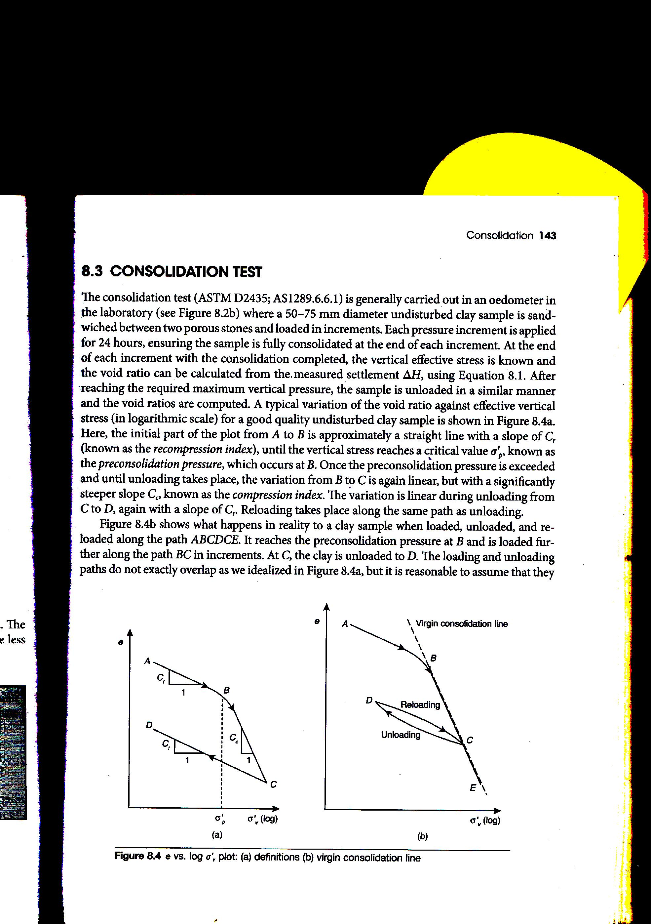The void-log ${{ σ}_{v}}^{'}$ plot is obtained by calculating the void ratio at the end of each load increment during one-dimensional consolidation testing and plotting it against the effective vertical stress on a logarithmic scale. A common plot for a saturated clay is evident in Figure 2.3.

**Figure 2.3: Void-log ${{ σ}_{v}}^{'}$ plot – (a) definitions (b) virgin consolidation line (****Sivakugan and Das 2009****)**

As the vertical load increases, it is evident that the void ratio decreases. Initially the curve has a slope equal to the recompression index (*Cr*) where the soil is overconsolidated. This slope continues until the preconsolidation pressure (${σ_{p}}^{'}$) is reached. After this point the slope of the curve follows a linear path, known as the Virgin Consolidation Line. A clay layer that consolidates along this line is said to be normally consolidated where the curve has a slope equal to the compression index (*Cc*). As the specimen is unloaded, it is evident that the slope of the curve is again approximately equal to the recompression index. It is assumed that the slopes of all recompression stages are approximately equal, as suggested by Leonards (1976). (Aysen 2002)

The preconsolidation pressure is defined as the maximum pressure that a consolidating layer has experienced. A soil stratum can be overconsolidated or normally consolidated which is determined in the laboratory in a one dimensional consolidation test. An overconsolidated clay is a clay that has experienced a past pressure (preconsolidation pressure) greater than that which is being applied. A normally consolidated clay however is one in which the load that is being applied is the maximum applied stress that the clay has experienced, and therefore lies on the virgin consolidation line.

The change in void ratio varies depending upon whether the clay is normally consolidated or overconsolidated. An overconsolidated clay results in significantly smaller settlements of a clay layer than would be experienced if the clay was normally consolidated, as the void ratio is smaller resulting in a smaller change in void ratio when a stress is applied (Sivakugan and Das 2009).

The change in void ratio for a normally consolidated clay is evident in Equation 2.8 and results from the movement of a point along the virgin consolidation line, having a slope of the compression index.

|  |  |  |
| --- | --- | --- |
|  | $$Δe= C_{c }\log{\frac{{σ_{vo}}^{'}+ {Δσ}^{'}}{{σ_{vo}}^{'}}}$$ | (2.8) |

The change in void ratio for an overconsolidated clay depends on whether the applied pressure is less than the preconsolidation pressure (${σ_{vo}}^{'} +{ Δσ}^{' }≤ {σ_{p}}^{'}$), with a relationship evident in Equation 2.9 or whether the applied pressure surpasses that of the preconsolidation pressure (${σ_{vo}}^{'} +{ Δσ}^{' }≥ {σ_{p}}^{'}$) with a relationship evident in Equation 2.10.

When ${{ σ}_{vo}}^{'} +{ Δσ}^{' }≤ {σ_{p}}^{'}$;

|  |  |  |
| --- | --- | --- |
|  | $$Δe= C_{r }\log{\frac{{σ_{vo}}^{'}+ {Δσ}^{'}}{{σ_{vo}}^{'}}}$$ | (2.9) |

When ${σ_{vo}}^{'} +{ Δσ}^{' }≥ {σ_{p}}^{'}$;

|  |  |  |
| --- | --- | --- |
|  | $$Δe= C_{r }\log{\frac{{σ_{p}}^{'}}{{σ_{vo}}^{'}}} + C_{c }\log{\frac{{σ_{vo}}^{'}+ {Δσ}^{'}}{{σ_{p}}^{'}}}$$ | (2.10) |

The change in void ratio can be substituted into Equation 2.7 as described in Section 2.3.1 to allow the total consolidation settlement to be determined. In order to determine the consolidation settlement at a particular time throughout the consolidation process however, Terzaghi’s one dimensional consolidation theory is utilised.

### Terzaghi’s One Dimensional Consolidation Theory

The theory to evaluate the rate of one dimensional consolidation was first proposed by Terzaghi (1925). Terzaghi’s theory can be used to compute the time rate of volume change, settlements and pore pressure of the soil (Coduto 1998). Terzaghi implemented the following assumptions to develop his theory.

The assumptions of Terzaghi’s Theory are:

1. Soil is homogenous - properties are considered consistent throughout;
2. Soil is fully saturated and solid particles and water are incompressible - no air is assumed to be present within the voids, and hence consolidation occurs due to the expulsion of pore water only;
3. Compression and flow are one-dimensional (vertical) - no strains are present within the horizontal direction resulting in drainage only occurring in the vertical direction;
4. Strains are small – the coefficient of permeability (*k*) and the coefficient of volume compressibility (*mv*) remain constant throughout the consolidation process;
5. Darcy’s Law is valid at all hydraulic gradients - the permeability remains directly proportional to the flow rate throughout the soil media; and
6. No secondary consolidation (creep) occurs – the relationship between void ratio and effective stress is dependent upon the consolidation process.

Terzaghi developed the following differential equation using the previous assumptions.

|  |  |  |
| --- | --- | --- |
|  | $$\frac{∂u}{∂t}=c_{v} \frac{∂^{2}u}{{∂z}^{2}}$$ | (2.11) |

where:

*cv* = coefficient of consolidation

The coefficient of consolidation can be determined by Equation 2.12 when the coefficient of volume compressibility and vertical permeability is known or can be found using data obtained from one dimensional consolidation tests with a method as outlined in Section 2.3.5.

|  |  |  |
| --- | --- | --- |
|  | $$c_{v }=\frac{k_{v}}{γ_{w}m_{v}}$$ | (2.12) |

where:

γw = the unit weight of the water.

Terzaghi’s differential equation for one dimensional consolidation can be considered as a diffusion equation for consolidation (Winterkorn and Fang 1990) and is similar to Fick’s Law of Thermal Diffusion.

A mathematical solution can be obtained from Terzaghi’s differential equation by applying appropriate boundary conditions, and using Fourier Series to obtain a series solution. The generalised solution for the initial excess pore water pressure is evident in Equation 2.13.

|  |  |  |
| --- | --- | --- |
|  | $$∆u\left(z,t\right)= ∆u_{0}\sum_{m=0}^{m=∞}{\frac{2}{M}}\sin\left(MZ\right)e^{-M^{2}T}$$ | (2.13) |

where:

|  |  |  |
| --- | --- | --- |
|  | $$M=\frac{π}{2} (2m+1)$$ | (2.14) |

|  |  |  |
| --- | --- | --- |
|  |  | (2.15) |

|  |  |  |
| --- | --- | --- |
|  |  | (2.16) |

In this series solution, both *T* and *Z* are dimensionless factors. The time factor (*T*) is dependent upon the coefficient of consolidation (*cv*), the length of the drainage path (*Hdr*), and the duration of loading (*t*) where application of load is considered to be constant with time. The depth factor (*Z*) is dependent upon the length of the drainage path and the depth in consideration below the soil stratum (*z*), commonly defined as the centre of the clay layer if determining total consolidation settlement.

The length of the drainage path is measured as the longest length that drainage can occur in one-dimension. If both boundaries (above and below) of the soil stratum are permeable, drainage is considered to be doubly drained and the drainage length is calculated as half of the total height of the clay layer (Hdr= H/2). If only one of these boundaries is permeable, the length of the drainage path is considered to be the total height of the clay layer (Hdr=H).

The length of the drainage path has a large effect on the rate of consolidation. When only one boundary is permeable, the time in which consolidation occurs is four times than that of two permeable boundaries as time is proportional to the height of the layer squared (t Hdr2).

Terzaghi’s series solution described in Equation 2.13 has been modified by Lovisa et al. (2013) to incorporate a time factor (*T\**) (see Equation 2.17) that is not dependent upon the length of the drainage path, where the *U-T* curve of a singly drained soil stratum and a doubly drained soil stratum can be individually graphed. This allows a comparison to be made between a singly and doubly drained soil stratum throughout the consolidation process. The series solutions to a singly and doubly drained soil stratum are described in Equation 2.18 and Equation 2.19 respectively, as derived by Lovisa et al. (2013).

|  |  |  |
| --- | --- | --- |
|  | *T\**= $\frac{c_{v}t}{D^{2}}$ | (2.17) |

Doubly drained:

|  |  |  |
| --- | --- | --- |
|  | $$u\left(z,t\right)= \sum_{n=1}^{∞}{A_{n}\sin\left(\frac{nπz}{D}\right)exp⁡(-n^{2}π^{2}}T^{*})$$ | (2.18) |

Singly drained:

|  |  |  |
| --- | --- | --- |
|  | $$u\left(z,t\right)= \sum_{m=1}^{∞}{A_{m}\sin\left(\frac{mπz}{2D}\right)exp⁡(\frac{-m^{2}πT^{*}}{4}})$$ | (2.19) |

where:

$A_{n}$*/Am* = the series coefficients determined from the initial pore water pressure distribution

*m* = 2n-1

**Degree of Consolidation**

The degree of consolidation is expressed as a percentage of excess pore water dissipated and represents conditions at a specific depth and time within the consolidating layer. The degree of consolidation is denoted by Uz(t) and is determined via Equation 2.20.

|  |  |  |
| --- | --- | --- |
|  | $$U_{z}\left(t\right)=1- \sum_{m=0}^{∞}{\frac{2}{M}}sin⁡(MZ)e^{{-M}^{2}T}$$ | (2.20) |

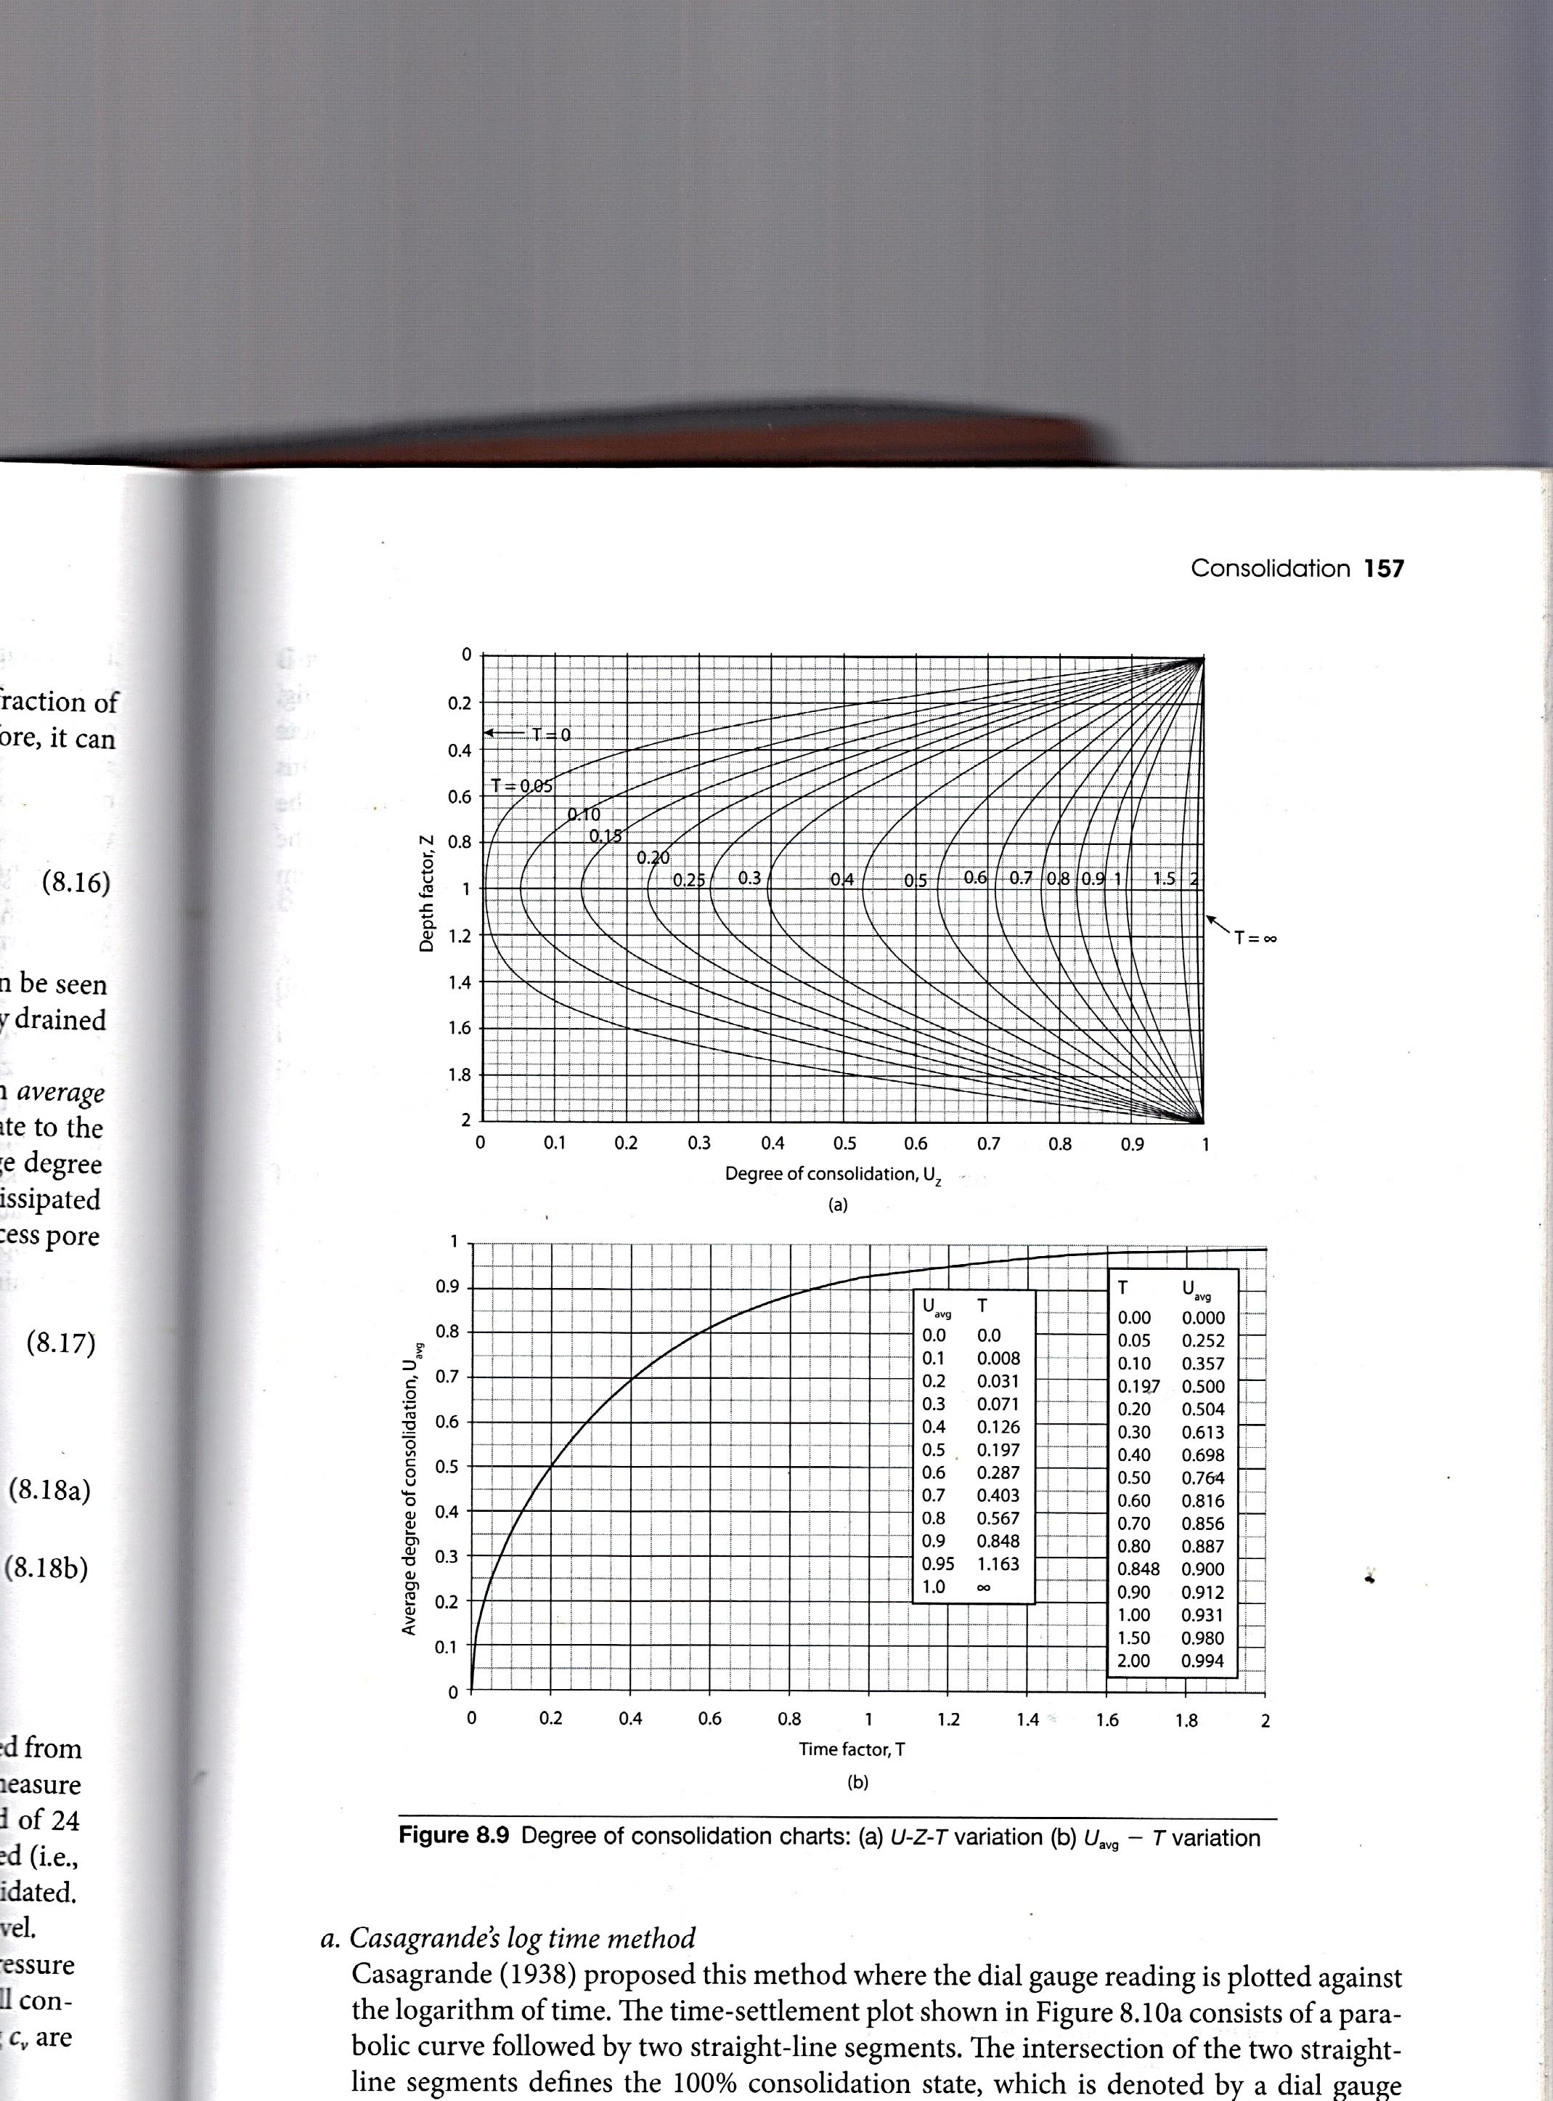The degree of consolidation can be determined from Figure 2.4 which uses isochrones for a given time factor throughout the depth of the compressible layer.

**Figure 2.4: Degree of Consolidation chart (U-Z-T variation)**

The degree of consolidation represents conditions specific to a depth and pressure. To determine a representative consolidation of the entire clay layer at a time (*t*), average degree of consolidation is used.

**Average Degree of Consolidation**

The average degree of consolidation allows the percentage of consolidation at a specific time to be determined. It is a relation of the excess pore water that has been dissipated at this time due to the load increment, to the undissipated excess pore water.

The average degree of consolidation is expressed in Equation 2.21.

|  |  |  |
| --- | --- | --- |
|  | $$U_{avg}\left(t\right)=1- \sum_{m=0}^{∞}{\frac{2}{M^{2}}} e^{{-M}^{2}T}$$ | (2.21) |

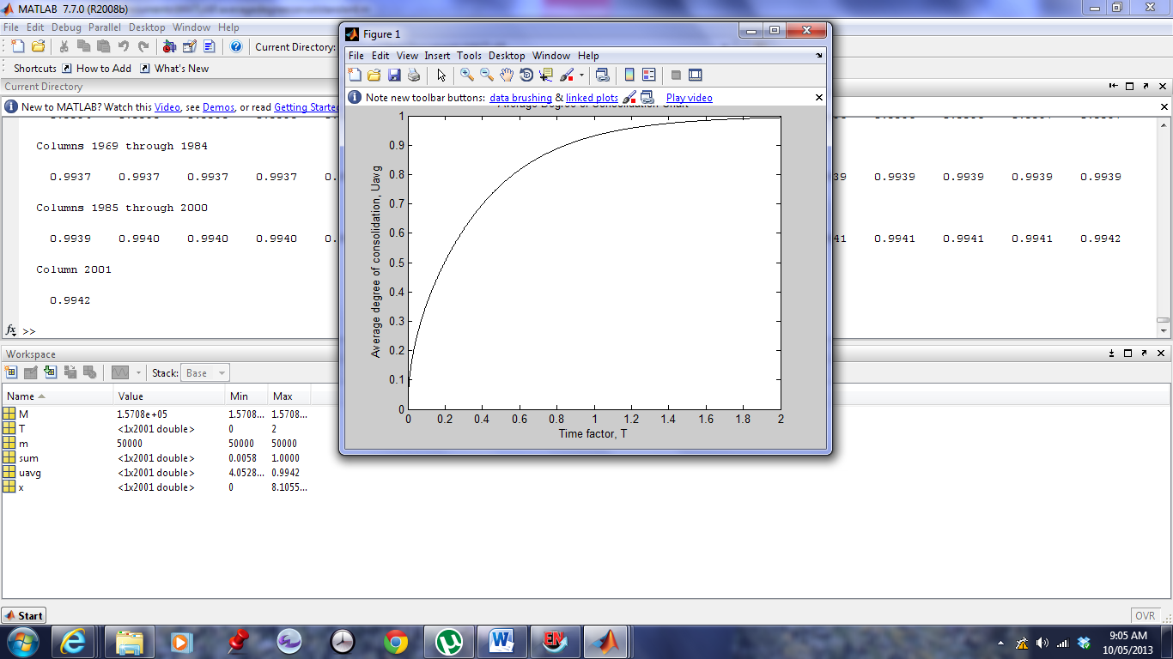A graph that relates the time factor (*T*) to the average degree of consolidation, utilising Equation 2.21 is evident in Figure 2.5.Matlab code to obtain this graph is described in Appendix A-1. Equations 2.18 and 2.19 would allow a graph of the average degree of consolidation to be obtained for both singly and doubly drained stratas.

**Figure 2.5: Average degree of consolidation chart (Uavg – T chart)**

This time factor in Figure 5 can be approximated as:

|  |  |  |
| --- | --- | --- |
| $$T= \frac{π}{4} {U_{avg}}^{2}$$ | $$for U_{avg}≤60\%$$ | (2.22) |

|  |  |  |
| --- | --- | --- |
|  |  | (2.23) |

The average degree of consolidation obtained from Figure 2.5 relies on a uniform distribution of excess pore water. As a uniform distribution does not always occur in reality, many investigations into this have been completed. Lovisa et al. (2010) considers various initial excess pore pressure distributions in one dimension in terms of average degree of consolidation. Average degree of consolidation curves (*U-T* curves) for various non-uniform initial excess pore water distributions are evident in Lovisa and Sivakugan (2013).

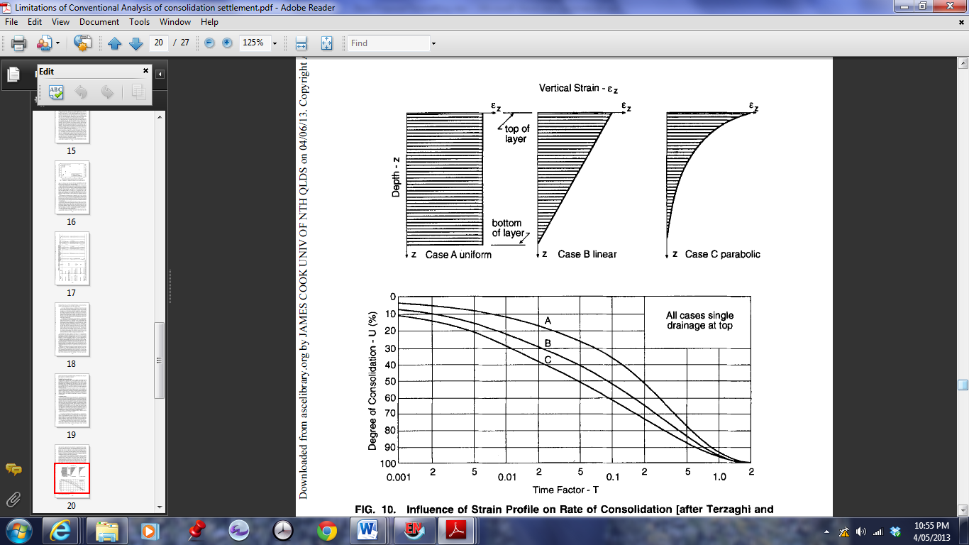The average degree of consolidation can also be calculated to incorporate linear and parabolic vertical strains through research conducted by Terzaghi and Frolich (1936) and (Duncan 1993), Janbu (1965), with the average degree of consolidation time curve (*U-T* curve) with respect to three different vertical strain distributions evident in Figure 2.6.

**Figure 2.6: Influence of Strain Profile on Rate of Consolidation Settlement (****Duncan 1993****)**

The average degree of consolidation is related to the total consolidation settlement (*sc,total*) by Equation 2.24.

|  |  |  |
| --- | --- | --- |
|  | $s_{c}= U_{avg} × s_{c,total}$ | (2.24) |

where sc,total is determined using Equation 2.7, as outlined in Section 2.3.1.

### Calculating Coefficient of Consolidation (cv)

The coefficient of consolidation (*cv)* is determined using the settlement-time plot obtained in one-dimensional consolidation testing for each load increment applied. Many methods have been developed to determine the coefficient of consolidation, with the most common being Casagrande’s (1938) log time method and Taylor’s (1948) square root of time method. These methods result in different values of *cv,* with Taylor’s method generally resulting in faster rates of consolidation (higher cv values). (Duncan 1993)

#### Casagrande’s Log Time Method

Casagrande’s log time method is outlined in AS1289.6.6.1-1998 as a method to determine the coefficient of consolidation for primary consolidation (*cv*) and also the coefficient of secondary compression ($c_{α}$) for secondary consolidation or creep. Figure 2.7 shows a typical consolidation settlement, where log time is in minutes and settlement is in millimetres (mm). This method relies on the determination of the 50 percent primary consolidation in a doubly drained condition, which is related to the coefficient of consolidation by Equation 2.25.

|  |  |  |
| --- | --- | --- |
|  | $$c_{v}= \frac{0.049 {H_{50}}^{2}}{t_{50}}$$ | (2.25) |

where:

*cv* = coefficient of consolidation in meters squared per year ( )

*H50*= thickness of the specimen, in millimetres (mm)

$t_{50}$ = time for 50 percent primary consolidation, in minutes

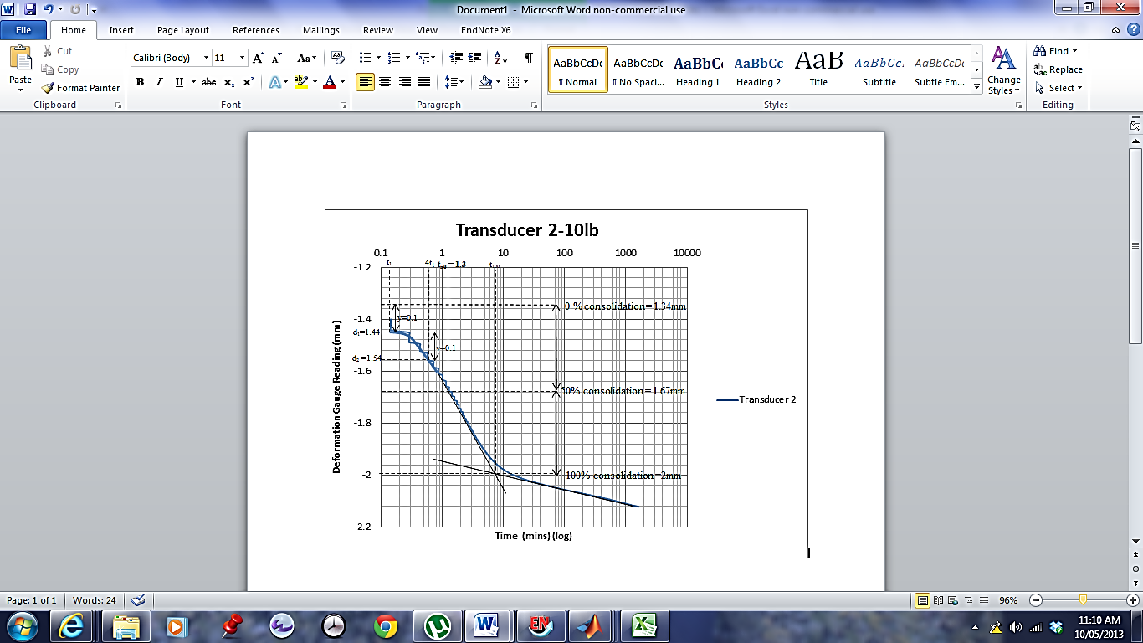

**Figure 2.7: Casagrande’s log-time method (using experimental results)**

To obtain the time for 50 percent primary consolidation, the settlement resulting from 0 and 100 percent consolidation are first determined. The initial reading is designated the time (*t1*) with the corresponding settlement reading (*d1*). The time corresponding to the initial time multiplied by four (*4t1*) is marked on the graph with its corresponding settlement reading (*d2*). The settlement of 0 percent consolidation can be determined by the difference between the settlement corresponding to 4t0 and the initial settlement reading (*d2-d1*), denoted y on Figure 2.7.

A tangent to the steepest part of the curve is drawn on the graph, as well as a tangent to the final points on the curve. At the intersection of these tangents, a horizontal line can be drawn, where it will extend to cross the curve. This point indicates 100 percent consolidation.

Once the settlement corresponding to 0 and 100 percent consolidation is established, the average of these settlements is obtained and marked on the curve and the corresponding time is determined as the time for 50 percent primary consolidation (t50).

#### Taylor’s Square Root of Time method

Taylor’s method is also presented as a method to calculate coefficient of consolidation (*cv*) in AS1289.6.6.1-1998, where settlement (in mm) is plotted against the square root of time (in minutes). Figure 2.8 shows the method of determining *cv* by Taylor’s method.

The coefficient of consolidation is determined through Equation 2.23 which relates the time of 90 percent consolidation to the average thickness of the consolidating layer for the doubly drained condition.

|  |  |  |
| --- | --- | --- |
|  | $$c_{v}= \frac{0.212 {H_{90}}^{2}}{t_{90}}$$ | (2.26) |

where:

$t_{90}$ = time for 90 percent primary consolidation, in minutes

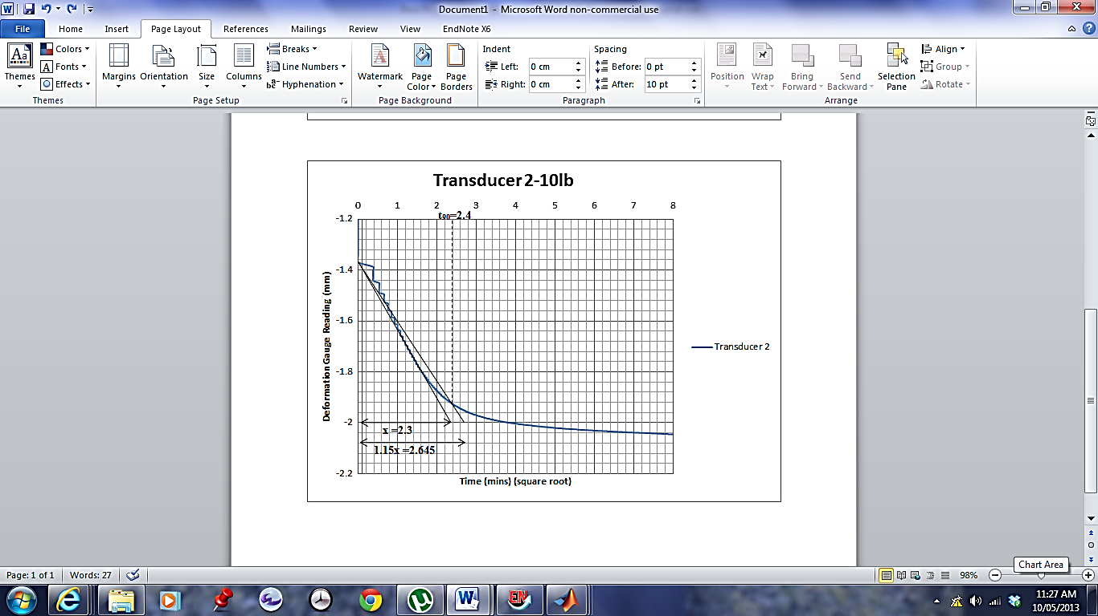*H90 =* thickness of specimen, mm

**Figure 2.8: Taylor’s square root of time method, using experimental results**

To quantify the time for 90 percent consolidation, a straight line is drawn through zero time and the initial portion of the curve, and the time at which the line finishes, denoted *x*. The time of 1.15*x* is marked on the plot at the same finishing length as the first line. A second line between the points of zero time and the 1.15*x* point is drawn, and the time at which it intersects the curve, determines the time for 90 percent primary consolidation.

#### Other methods to calculate Coefficient of Consolidation

Although Casagrande’s and Taylor’s graphical method are most widely used, other methods to calculate the coefficient of consolidation have been developed. One of these is the Inflection Point Method, developed by Mesri et al. (1999) that uses visual inspection of the point of transition from primary consolidation to secondary consolidation from a consolidation-log time curve to determine the coefficient of consolidation. Results from this method correlate with the coefficient of consolidation obtained from Casagrande’s method.

Asaoka (1978) proposed both a graphical approach and autoregressive prediction model to calculate the coefficient of consolidation, which is determined as suitable for settlement prediction. A Rectangular hyperbola method of consolidation analysis was derived by Sridharan et al. (1987) as a simpler method to predict the coefficient of consolidation which gives results comparable to Casagrande’s and Taylor’s method.

Lovisa and Sivakugan (2013) compared the values of the coefficient of consolidation obtained from Casagrande’s log time method, Taylor’s square root of time method and the Cour Inflection point method, as well as deriving a new method and comparing results obtained from this. The method suggested within this paper uses a technique that fits all data points to the curve in order to determine the coefficient of consolidation, compared to Taylor’s and Casagrande’s method which only fits one.

Numerous other methods have been derived to determine the coefficient of consolidation, many which include variations to overcome assumptions of Terzaghi’s theory (Sridharan et al. 1987). One of these such methods is proposed by Lovisa et al. (2012) where non-uniform initial excess pore water pressure is taken into consideration when calculating the coefficient of consolidation.

## Two and Three Dimensional Consolidation

Two dimensional consolidation consists of drainage and strains in both the vertical direction and one horizontal plane, where three dimensional radial consolidation is approximated as two dimensional consolidation . Two dimensional consolidation occurs beneath a strip load (Barnes 1995) where a plane strain condition exists.

Consolidation in three dimensions takes into consideration drainage in the vertical direction and both horizontal planes. Three dimensional consolidation occurs beneath a circular, square or rectangular footing (Barnes 1995) or in a consolidating layer with a large depth compared to width and length.

It has been suggested by Davis and Poulos (1972) that the horizontal dissipation of pore pressure results in a rate of consolidation that is more rapid of which is not considered within one dimensional consolidation theory. Davis and Poulos (1972) also noted that three dimensional consolidation theory is not commonly used due to minimal theoretical practical solutions having been obtained for these.

### Two and Three Dimensional Consolidation Theories

Two and three dimensional consolidation theories have been developed by Terzaghi (1925) and Rendulic (1937) based on the diffusion theory, and by Biot (1941) in his elastic theory (Razouki and Al-Zayadi (2003); Poulos and Davis (1968)).

A comparison has been made between these theories by Poulos and Davis (1968) and Murray (1978), and outlined in Razouki and Al-Zayadi (2003) where it is concluded that although Biot’s theory allows the Mandel-Cryer effect to be taken into consideration where the diffusion theory does not, the diffusion theory of consolidation results in pore pressure estimates at the end of consolidation that can be deemed sufficiently accurate. These results suggest that although Biot’s method is a complete consolidation theory, the difficulty in using the method and the limited solutions to practical problems results in its minimal use.

Other differences between the methods arise from the calculation of the coefficient of consolidation. Rendulic’s equations will assume a single value of the coefficient of consolidation to be used in one, two and three dimensional consolidation calculations whereas Biot’s theory identifies that this value depends on strain, resulting in the use of different coefficients of consolidation in each of these calculations (Murray 1978).

Terzaghi and Rendulic’s equation of consolidation can be considered a pseudo consolidation equation due to existing in an uncoupled form. Biot’s theory can be considered a complete theory of consolidation due to its coupled form where both Darcy’s law and mechanical deformation compatibility are taken into account (Davis and Poulos 1972).

#### Vertical Drains

Two dimensional consolidation has been considered by Barron (1948) with the use of sand (vertical) drains. Vertical drains are used in field situations to accelerate the rate of consolidation. This is completed by allowing pore water to dissipate at a faster rate in the horizontal direction by creating shorter horizontal drainage paths (Barnes 1995).

As the consolidation process of a vertical drain is dependent upon the coefficient of consolidation and the permeability in the horizontal and vertical directions, an equation was derived by Barron (1948) to quantify the degree of consolidation in the horizontal direction. Carillo (1942) also quantified this process (Hong and Shang 1998).

#### Numerical Models

Numerical models for consolidation problems are often developed in order to quantify suitable parameters for use in determining the settlement properties of a consolidating layer. They allow coupled formulations such as Biot’s theory to be implemented such that solutions to consolidation problems can be determined without the difficulty of analytical methods.

Borges (2004) implemented a numerical model based finite element method to determine the effect of vertical drains on soft soils to the rate of consolidation. A three dimensional analysis was completed with the use of Biot’s consolidation theory, with results showing a large reduction in total time of consolidation.

Many other numerical models have been developed of which overcome assumptions incorporated within Terzaghi’s one dimensional consolidation theory. A numerical prediction of large-strain consolidation was undertaken by Bartholomeeusen et al. (2002) where numerical models were implemented by various ‘participants’. All determined consolidation settlements were deemed to be accurate as a prediction of settlement in large strain situations, however the importance of initial parameters and assumptions were noted.

## Application – Land Reclamation

The determination of two and three dimensional consolidation has many field applications. This includes the application of land reclamation, with such examples including the Port of Brisbane, Queensland where land reclamation is currently being undertaken, and previous land reclamation projects such as Bay Farm Island in San Francisco Bay and Kansai International Airport in Japan (Duncan 1993).

Land reclamation involves erecting permeable rock and sand seawalls in the direction of the ocean in order to acquire land. Fill material such as sands and gravels are generally used due to their drainage properties and are common to projects such as Bay Farm Island in San Francisco Bay and Kansai International Airport in Japan. This however results in an economically exorbitant cost as evident in Japan, where the cost of the fill alone for the artificial island of 4.3 km long, 1.3 km wide and 33 m thick and containing one hundred and eighty four million cubic meters of fill was three billion, six hundred million dollars (Duncan 1993).

The importance of two and three dimensional consolidation to these applications arises when considering the underlying material of the acquired land. Bay farm Island was underlain by San Francisco Bay mud of 6 – 15 m, and Kansai International Airport underlain by approximately 20 m of soft alluvial clay followed by greater than 150 m of diluvial clay (Duncan 1993).

As outlined by Duncan (1993) in the Twenty-Seventh Karl Terzaghi Lecture, many problems arose with the determination of the magnitude and rate of consolidation settlement at these locations. One of the limitations identified was that of conventional consolidation theories in determining a suitable value of the coefficient of consolidation. The rate at which settlement occurred varied greatly depending on the coefficient of consolidation determined, generally resulting in an over prediction of the time rate of consolidation. The paper identified the benefit that would be obtained in using a two dimensional model to determine the rate of consolidation.

### Port of Brisbane, Queensland, Australia

The Port of Brisbane land reclamation project involves the acquisition of approximately 235 hectares of additional land by implementing a 4.6 km long rock and sand seawall as the perimeter of the containment area (Ganesalingam et al. 2012b). The area is further segregated by containment bunds, where fill material is then placed (see Figure 3.1)

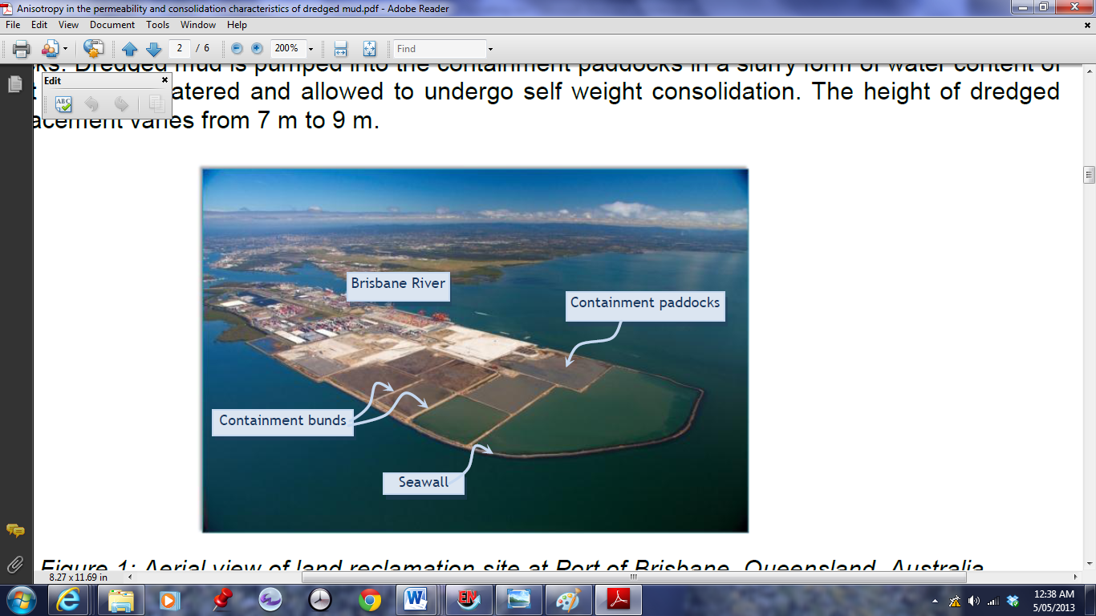**Figure 3.1: Aerial view of land reclamation at the Port of Brisbane (****Ganesalingam et al. 2012a****)**

As previously identified, filling these containment bunds with a material such as sand would incur an economically exorbitant cost and hence, the contained bunds are filled with dredged materials, not only providing a cheaper alternative, but creating an environmentally friendly means of disposing of dredged materials (Ganesalingam et al. 2012b). As both the dredged materials and Holocene clay layer underlying the containment bunds have poor drainage properties and compressibility (Ganesalingam et al. 2012a), the process of consolidation can be timely.

In order to accelerate consolidation, ground improvement techniques are used such as vertical drains and preloading with sand when a suitable bearing capacity has been achieved. Due to the simultaneous drainage that occurs by the vertical drains and the permeable containment bunds, a three dimensional consolidation process arises.

The Port of Brisbane currently uses numerical software called CAOS (Consolidation Analysis of Soils) that uses past consolidation settlement rates to determine future rates.

Limitations in consolidation theory results in the difficulty of the estimation of the rate of settlement, with one dimensional consolidation theory possibly overestimating the time taken for consolidation to be achieved. This highlights the importance and necessity of the time rate of two and three dimensional consolidation to be quantified, where results can then be compared to CAOS software.

# Research and Methodology

## Objectives

The primary objective of this thesis is to determine the effect that two and three dimensional consolidation will have on the time rate of consolidation. Average degree of consolidation (*U*) and time factor (*T)* curves (*U-T curves*) will be analysed with respect to two and three dimensional consolidation, and comparisons will be made to one dimensional *U-T* curves. Suitable *U-T* graphs for two and three dimensional consolidation will then be determined based upon this analysis, along with possible adjustment factors and/or design charts.

## Methodology

These objectives will be achieved by using analytical, experimental and numerical solutions. Numerical models will be developed in FLAC and compared to experimental results for validation. The analytical solution will also be validated by comparing results with those obtained experimentally.

### Experimental Analysis

A variety of one dimensional, two dimensional and three dimensional consolidation experiments will be conducted on kaolinite clay. A sample of the Port of Brisbane dredged material will be used in the apparatus discussed further for each of the one, two and three dimensional consolidation experiments.

#### Sample Preparation

An artificial soil sample was prepared using kaolinite clay in a dry powdered form mixed with water to form slurry of water content of 140%. The amount of kaolinite clay that was prepared will allow enough material for the various laboratory tests to be conducted, ensuring consistency of the properties between tests.

In order to consolidate the kaolinite clay in one, two or three dimensions, the slurry was consolidated to a state in which it was ‘firm’ and was able to hold its form within a consolidation ring. The strengthening consolidation stage can be completed in a settling column or a tall oedometer.

In a settling column apparatus, the slurry is placed in a tall cylindrical settling column of dimensions of height 810 mm and diameter 107 mm, with a porous plate at the base and top of the sample. The slurry is to be left to consolidate under its own self weight, and after a period of time when the settlement begins to slow, additional pressure is added to the sample by means of weights ranging from 100 g to 3000 g. When the settlement of the slurry becomes minimal with time as the load is increased, it can be extruded. This method would require approximately eight weeks (Ganesalingam et al. 2012b).

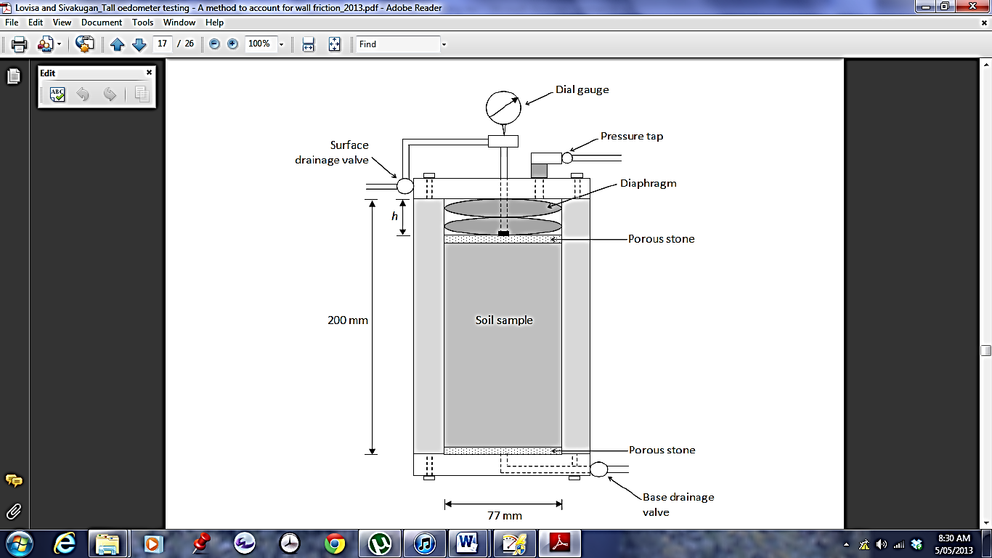The other method to prepare the sample to a stage to which it can be extruded is the tall oedometer method, as outlined by Lovisa (2013) with apparatus evident in Figure 3.2. This method relies on the consolidation of the sample by application of increasing hydraulic pressure with time, allowing the sample to consolidate and reach a state in which it can be extruded within a shorter period of time than that of the settling column.

**Figure 3.2: Tall Oedometer Schematic (****Lovisa 2013****)**

Due to the shorter time required for the strengthening consolidation stage when the tall oedometer is used, this method was used. The slurry was placed in the tall oedometer, with a porous stone above and below the sample allowing it to be doubly drained. A low hydraulic pressure was applied, and the sample was left to consolidate for approximately 24 hours, or until it achieved very little consolidation at the applied pressure. The pressure was increased until the diaphragm became too extended in which the apparatus was disassembled and a spacer stone placed on top of the sample. The diaphragm was reassembled and pressure further increased to 160 kPa , where the sample was between 5 and 7 cm, corresponding to a 40-60 % moisture content. The sample was then extruded for use within the standard consolidation apparatus. The tall oedometer procedure for slurry preparation is described in Appendix 2 (A-2).

To ensure homogeneity of the sample, water contents were determined from three points within the sample upon extrusion.

#### One-Dimensional Consolidation

Standard one-dimensional consolidation tests will be completed to *AS1289.6.6.1-1998: Soil strength and consolidation tests-Determination of the one-dimensional consolidation properties of a soil-Standard Method*. These will be completed on a sample of 63 mm diameter, and with loading increments 1 kPa and 2500 kPa. The 63 mm consolidation ring diameter will be utilised to reduce the effects edge disturbance of the extruded sample from the 77 mm diameter tall oedometer.

The sample to be tested in the one-dimensional consolidation tests will be of both vertically and horizontally cut samples. This will allow both vertical and horizontal coefficients of consolidation to be determined for each loading increment and a relationship between these to be determined. It is documented that the coefficient of consolidation in the horizontal direction is greater than that of the vertical direction, however this is “an uncritical and generalised assumption” (Hansbo et al. 1981) that may not always be justified.

Due to the relationship between permeability and coefficients of consolidation in both the horizontal and vertical direction, permeability will be measured in conjunction with a standard oedometer with a permeability rowe cell. This will allow the permeability anisotropy to be quantified, and hence the obtained values of the vertical and horizontal coefficients of consolidation to be validated through the use of Equation 2.12. The permeability rowe cell requires a sample of 73 mm diameter due to the apparatus configuration.

#### Two Dimensional Consolidation

A new apparatus for two-dimensional consolidation will be used to determine the rate of consolidation in two dimensions. A medium oedometer with a height of 63 mm and diameter of 63 mm (height/diameter ratio of 1) will be used in the standard consolidation apparatus, following the same procedure as one-dimensional consolidation. The medium oedometer will be porous at the top and bottom of the sample by utilising porous stones, and throughout the effective height of the circumference through the use of porous material. The proposed schematic is evident in Figure 3.3.

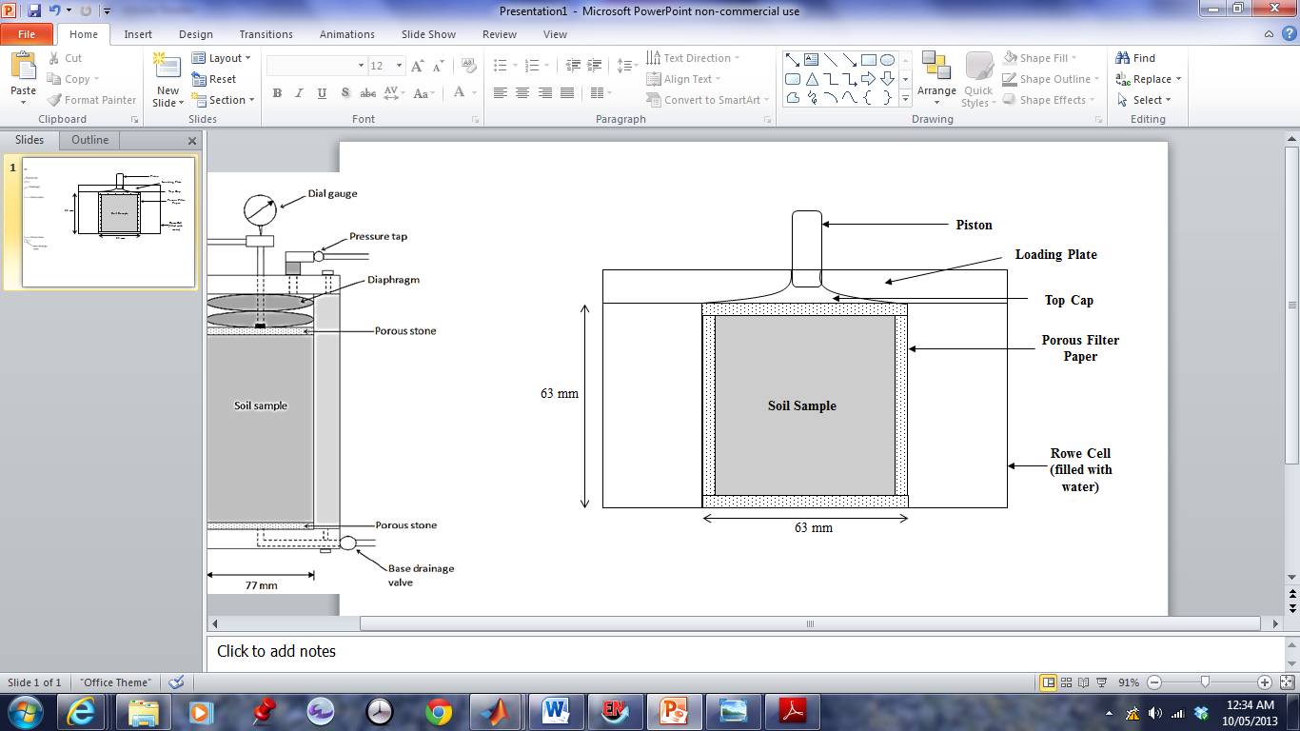This will allow both radial drainage and vertical drainage, and therefore two-dimensional consolidation will be evident. A time-settlement curve will result from this experiment, and the coefficient of two dimensional consolidation can be determined.

**Figure 3.3: Proposed two dimensional consolidation apparatus schematic**

#### Three Dimensional Consolidation

In order to simulate three dimensional consolidation, a square apparatus is proposed with porous material along the walls to allow for drainage. It is proposed that a square box of side length 60mm and height of 60 mm is used, where a porous material will be placed on the top and bottom, and two sides (sides to be adjacent). This will allow two planes of horizontal drainage, and vertical drainage, allowing three dimensional consolidation to be quantified.

Due to the configuration of the sample, a new rowe cell will be required to determine. This apparatus will then be placed in the oedometer where a time settlement curve will result as loads are applied. This curve will allow the coefficient of three dimensional consolidation to be determined.

### Analytical Analysis

Terzaghi’s one-dimensional consolidation theory will be extended to two dimensions analytically, allowing the expected settlement and time rate of consolidation to be determined.

Although analytical solutions to two and three dimensional consolidation have been previously derived, as evident in Section 2.4, the two dimensional analytical solution derived for the use of this thesis aims to obtain a solution with varying user inputs. Through the use of MATLAB, a generalised theory will be implemented and the user can input variables such as initial excess pore water distributions and variable initial loading conditions.

The analytical solution will be verified by comparing results with those obtained during experiments conducted on kaolinite and the Port of Brisbane dredged material.

### Numerical Analysis

Numerical Analysis will be completed in FLAC (Fast Lagrangian Analysis of Continua), an explicit finite element program. A model simulating the experiments in two and three dimensions will be developed and compared to experimental results for validation. Once the model has been validated, the height/diameter ratio can be varied and corresponding U-T curves evaluated to determine a relationship between the one dimensional corresponding U-T curves.

The numerical analysis will also be extended to situations such as the Port of Brisbane, where a two layered, non-homogeneous consolidating layer with partial drainage boundaries, a non-uniform distribution of excess pore water pressure and time-dependent surcharge loading is evident.

# Project Management Plan

## Timeline

Figure 3.4 shows the expected timeline for the thesis of Three Dimensional Consolidation, with milestones evident in May when the thesis proposal is to be finalised and Novemeber when the final thesis is to be presented.

The laboratory testing is expected to continue until the 26th August, with the following testing being undertaken:

* Three, one dimensional consolidation tests without permeability testing
* One, one dimensional consolidation test with permeability testing
* Three, two dimensional consolidation tests
* Three, three dimensional consolidation tests

The completion date of the expected testing allows sufficient time for additional testing if required, and also accounts for delay. A comprehensive testing outline is evident as Appendix A-3.

|  |  |  |  |  |  |  |  |  |  |
| --- | --- | --- | --- | --- | --- | --- | --- | --- | --- |
| Task | March | April | May | June | July | August | September | October | November |
| Thesis Proposal |  |  |  |  |  |  |  |  |  |
| Laboratory Testing |  |  |  |  |  |  |  |  |  |
| Numerical Modelling |  |  |  |  |  |  |  |  |  |
| Experimental Analysis |  |  |  |  |  |  |  |  |  |
| Thesis |  |  |  |  |  |  |  |  |  |

**Figure 3.4: Expected thesis timeline**

## Resource Planning

The resources have been allocated between the thesis groups, and the experimental timeline developed accordingly. It is expected that after the initial use of the tall oedometer by another group, no further resources will have to be shared.

It has been accounted for, that the tall oedometer and two standard oedometers will be available for sole use throughout the duration of testing.

## Risk Analysis

A comprehensive risk analysis has been completed and is evident in Appendix A-4. It is evident that with the precautionary measures implemented, no risks exceed a low level.

## Cost Analysis

A value of two hundred and fifty dollars has been allocated to each thesis student. With the thesis partnership, a value of five hundred dollars is available for use. Eighty dollars is required for the use of the Scanning Electron Microscope of the kaolinite sample to determine particle orientation. Apart from this, no further costs are expected at this stage.

#### References

AS1726-1993: Geotechnical Site Investigations

AS1289.6.6.1-1998: Soil strength and consolidation tests-Determination of the one-dimensional consolidation properties of a soil-Standard Method.

Asaoka, A. (1978). "Observational procedure of settlement prediction." Soils and foundations 18(4): 87-101.

Aysen, A. (2002). SOIL MECHANICS Basic Concepts and Engineering Applications. The Netherlands, A.A Balkema Publishers.

Barnes, G. E. (1995). Soil Mechanics, Principles and Practice. Palgrave.

Bartholomeeusen, G., Sills, G., Znidarcic, D., Van Kesteren, W., Merckelbach, L., Pyke, R., Carrier, W., Lin, H., Penumadu, D. & Winterwerp, H. (2002). "Sidere: numerical prediction of large-strain consolidation." Geotechnique 52(9): 639-648.

Borges, J. L. (2004). "Three-dimensional analysis of embankments on soft soils incorporating vertical drains by finite element method." Computers and Geotechnics 31(8): 665-676.

Coduto, D. P. (1998). Geotechnical Engineering: Principles and Practices. United States of America, Prentice Hall.

Das, B. M. (1984). Principles of Geotechnical Engineering. Thompson Canada Limited, Chris Carson.

Davis, E. H. & Poulos, H. G. (1972). "Rate of settlement under two- and three-dimensional conditions." Geotechnique 1(22): 95-114.

Duncan, J. M. (1993). "Limitations of conventional analysis of consolidation settlement." Journal of Geotechnical Engineering 119(9): 1333-1359.

Ganesalingam, D., Ameratunga, J., Scweitzer, G., Boyle, P. & Sivakugan, S. Anisotropy in the permeability and consolidation characteristics of dredged mud. ANZ 2012 Conference Proceedings. Ground Engineering in a Changing World: 11th Australia - New Zealand Conference on Geomechanics 2012a Melbourne, VIC, Australia pp. 752-757.

Ganesalingam, D., Sivakugan, N. & Ameratunga, J. 2012b. *Influence of settling behavior of soil particles on the consolidation properties of dredged clay sediment*.

Graham, J. & Houlsby, G. T. (1983). "Anisotropic elasticity of a natural clay." Geotechnique 33(2): 165-180.

Hansbo, S., Jamiolkowski, M. & Kok, L. (1981). "Consolidation by vertical drains." Geotechnique 31(1): 45-66.

Hong, H. & Shang, J. (1998). "Probabilistic analysis of consolidation with prefabricated vertical drains for soil improvement." Canadian geotechnical journal 35(4): 666-667.

Janbu, N. (1965). "Consolidation of clay layers based on non-linear stress-strain."

Lovisa, J. 2013. *An Insight into Time Rate of Consolidation, PHD Thesis.* James Cook University.

Lovisa, J., Read, W. & Sivakugan, N. (2010). "Consolidation behavior of soils subjected to asymmetric initial excess pore pressure distributions." International Journal of Geomechanics 10(5): 181-189.

Lovisa, J., Read, W. & Sivakugan, N. (2012). "Calculating c v based on non-uniform initial excess pore pressure." Geotechnique 62(8): 741-748.

Lovisa, J., Read, W. & Sivakugan, N. (2013). "Time Factor in Consolidation: Critical Review." International Journal of Geomechanics 13(1): 83-86.

Lovisa, J. & Sivakugan, S. (2013). "An in-depth comparison of cv values determined using common curve-fitting techniques." Geotechnical Testing Journal 36: 1-10.

Mesri, G., Feng, T. & Shahien, M. (1999). "Coefficient of consolidation by inflection point method." Journal of geotechnical and geoenvironmental engineering 125(8): 716-718.

Murray, R. (1978). "Developments in Two and Three-Dimensional Consolidation Theory." Developments in Soil Mechanics–1.

Peng, D. X. (2011). GLINSKI, J., HORABIK, J. & LIPIEK, J. The Netherlands, Springer. 55-57.

Poulos, H. G. & Davis, E. H. (1968). "The Use of Elastic Theory for Settlement Prediction Under Three-Dimensional Conditions." Géotechnique 18(1): 67-91.

Razouki, S. S. & Al-Zayadi, A. A. (2003). "Design Charts for 2D Consolidation under Time-Dependent Embankment loading." Quarterly journal of engineering geology and hydrogeology 36(3): 245-260.

Sivakugan, N., Chameau, J. & Holtz, R. (1993). "Anisotropy studies on cuboidal shear device." Journal of geotechnical engineering 119(6): 973-983.

Sivakugan, N. & Das, B. M. (2009). Geotechnical engineering: a practical problem solving approach. J Ross Pub.

Sridharan, A., Murthy, N. & Prakash, K. (1987). "Rectangular hyperbola method of consolidation analysis." Geotechnique 37(3): 355-368.

Terzaghi, K. & Frolich, O. (1936). "Theory of settlement of clay layers." Leipzig: Franz Deuticke.

Ti, K. S., Huat, B. B., Noorzaei, J., Jaafar, M. S. & Sew, G. S. (2009). "A review of basic soil constitutive models for geotechnical application." Electronic Journal of Geotechnical Engineering 14: 1-18.

Winterkorn, H. F. & Fang, H.-Y. (1990). Foundation Engineering Handbook. United States of America, Kluwer Academic Publishers.

Raw Data

Matlab Code for Average Degree of Consolidation-Time Factor Graph

%setting sum to 0, used as a counter

sum=0;

%Time factor values

T=0:0.001:2

%Setting up the sum of (between m=0 to 'infinity') as the function converges quickly, 50 000 will obtain a suitable result

for m=0:50000;

%determing M factor

M=(pi/2)*(2*m + 1);

%letting x be the sum portion of the avg degree of consolidation equation

x=(2/M^2)*2.718281828.^(-(M^2).*T);

%sum is a counter, adds the additional x values for each iteration of m

sum=sum+x;

end

%determining u average

uavg=1-sum

%Plotting graph

plot(T,uavg, 'k')

%setting up the axis

axis([0 2 0 1])

title('Average Degree of Consolidation Chart')

xlabel('Time factor, T')

ylabel('Average degree of consolidation, Uavg')

Tall Oedometer Procedure for Preparation of Slurry Sample

The tall oedometer apparatus is initially disassembled into three components; the base, the perspex cell and the top containing the diaphragm.

1. A filter paper cut to size is placed on the base of the tall oedometer.
2. The perspex cell is placed on top of the base in line with the bolt holes. For a simple method to insert and tighten the bolts, the perspex cell is turned upside down.
3. The bolts are tightened to an even pressure, where they are then further tightened. It should be ensured that the bolts are not tightened too much as to break the perspex.
4. All drainage valves are turned ‘off’.
5. The apparatus is then turned upright, and the slurry is placed into the perspex tube with a funnel and scoop. The mixture is filled to a height approximately 3 cm from the top.
6. A knife is used to mix the sample in the column, to minimise the present voids. The column is then placed on the vibratory machine for approximately 30 seconds to further remove any voids.
7. If the slurry is viscous, the following steps can be completed straight after the vibration. If the slurry however is very liquid, it is left to sit overnight where the excess water can be removed before continuing further.
8. A porous filter paper is placed on top of the sample, along with a filler stone. Note: This stone should be porous if double drainage is required.
9. The top cap is placed on the column, with the diaphragm inserted into the top of the column, ensuring the diaphragm is at an even level (inserted properly).
10. The top bolts are inserted and evenly tightened, where further tightening can then occur.
11. The tall oedometer apparatus is placed in the triaxial apparatus, where the pressure hose (Number 2) is inserted into the pressure outlet at the top of the sample.
12. A small pressure (approximate 5 kPa) is applied (pressure valve ‘open’) to fill the diaphragm with water until the centre bolt hole slightly overflows.
13. The centre bolt is wrapped in plumbers tape (leak resistant) and screwed into the top. This bolt can be done up very tightly.
14. The dial gauge is placed on top of the hydraulic lever that applies pressure to record the settlement of the sample that occurs. The dial gauge is ‘zeroed’ at this point.
15. A small pressure of 10 kPa is applied to the sample, and the pressure valve and drainage valve is turned on ‘open’, where settlement of the sample can then begin.
16. It is important to ensure that the volume change dial does not exceed 4.0, in which case the pressure lever is to be turned in the opposite direction. When the dial gauge is fully extended, the reading can be recorded and the dial gauge ‘zeroed’.
17. Hydraulic pressure is increased when the dial gauge reading is minimal with time. It is standard to increase in double increments. I.e. 10, 20, 40, 80, 160 kPa.
18. When approximately 30 mm of travel has occurred, a filler is required, and the apparatus is to be disassembled. The pressure is turned off, and the tap removed. The drainage tap is also turned off. The top cap is removed, and another filler placed on top. The hydraulic lever is ‘oiled’ to ensure constant application of pressure, and steps 10 to 14 are repeated.
19. The sample is ready for extrusion when settlement is minimal with time, and with a substantial pressure, indicating a stiff sample.

Detailed Experimental Timeline

***Risk Analysis***